Welcome to

*

* Kindergarten In Developmental Stages

Worcester, Massachusetts

A Message to Parents

Children and parents look forward with a great deal of excitement to the first day of school.

Although many children today have experienced preschool programs, Kindergarten is the first, and perhaps the most important, step to their formal education.

We hope that this booklet will assist parents in understanding the purpose of Kindergarten and what we hope our young students will accomplish during this year. Parents are urged to review this information and to work closely with their children, the teacher and the school. By doing this, Kindergarten will be a delightful experience for our young students and will enable them to move to the higher grades with confidence in their ability to succeed. Please assist us in our efforts.

Have a wonderful year with your child!

By working together, it can be one of the happiest and most successful in his/her life as well as yours.

What is

?

Kindergarten In Developmental Stages (K.I.D.S.) is a community of spontaneous, eager, curious and friendly young children. Although still firmly attached to home and family, they are beginning to discover the world of people around them.

Entering Kindergarten is a very special day for you and your child. The full day Kindergarten program will strengthen, complement, and extend experiences which have roots in the home. Your child’s early years are recognized as one of the most important periods in his/her development. The kindergarten year offers parents and teachers the opportunity to establish a relationship based on mutual confidence and respect which helps both to understand more clearly the behavior, growth, and adjustment of the child. The children are guided through a variety of “hands- on” experiences to gain self-confidence, solve problems, and work and play independently.

K.I.D.S.
Shows Evidence of:

Learning Centers
Learning centers such as block building,
art activities, music activities, language arts, math, dramatic play, writing, and science are arranged throughout the classroom.

Activity
Learning occurs when children are actively involved. Manipulative materials are the real “books and papers” in a developmentally appropriate Kindergarten program. Teachers guide, support, and teach individual children or work with small groups of children.

Balance
Activity is balanced with periods of quiet and rest. There is a balance between individual, small group and large group instruction. Cognitive activities (those requiring mental activity) are balanced with those designed to promote children’s social, emotional and physical needs.

The Characteristics of Young Children
The characteristics of young children and the knowledge of how children learn are the foundations of the developmentally appropriate Kindergarten program.
Research documents that young children are:
- active – mentally, physically and socially
- developing control over small and large muscles
- learning to use speech and language but still have undeveloped auditory and visual perception
- curious – instinctively driven to explore, find out, experiment
- striving to learn and be productive
- sensitive and will go out of their way to avoid anything unpleasant or unsuccessful
- attentive for long periods of time if they have chosen the activity
- in the “good boy/girl” stage of morality and want to please adults
- vulnerable and fragile, in need of protection, attention, love and security

General School Procedure

School Hours
All parents will receive a letter in August specifying the date and time that each child will start school.

School Calendar
Just before school starts, the Sunday Telegram will publish a School Calendar listing vacations, holidays and professional development days. The calendar can also be found on the Worcester Public Schools web page, www.worcesterschools.org.

Arrival
Have your child arrive at school no more than fifteen minutes before the beginning of school when school crossing guards and teaching staff are on duty.
Punctuality and regularity of attendance are important to the child from the very first day of school. The earlier your child learns that school is his/her job and that he/she has something important to do, the more satisfactory will be his/her growth and development.

Absences
When it is necessary for your child to be absent, an explanatory note must be sent to the teacher (when the child returns to school) in accordance with State Law, Chapter 119, Section 69.

Late
If, and when, it is necessary for your child to be late, please send an explanatory note to the teacher.

Dismissals
Dismissals will be allowed upon parent or guardian request (by telephone or note). The parent or guardian must appear at the office for the child.

Educational Tips
An integral part of the educational program is the inclusion of field trips. Such trips are taken to enrich a child’s classroom experiences. All trips are correlated with the educational program and are carefully planned and supervised by the classroom teacher. Children who are invited to take these trips are required to bring to school a permission slip signed by a parent or guardian prior to the day of the trip.

Student Records Regulations
Chapter 71, Massachusetts general Law, Section 34A, 34B, 34E. Parents and legal guardians have the legal right to examine their child’s school records. If at any time you wish to see your child’s records, you should contact your principal for an appointment. It is advisable that a trained professional review the records with you and interpret the records for you.

Screening
In compliance with Public Law, IDEA-94142, each Kindergarten child is evaluated early in the school year. The results of this evaluation help to determine potential strengths and weaknesses in a child’s learning ability and to assist the teacher in developing appropriate classroom programs.
Special services are available to those children whose screening indicates the need for additional assistance.
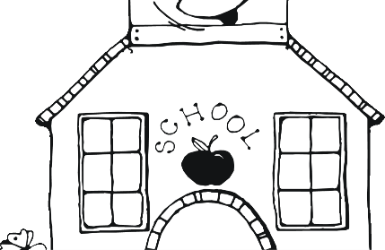

Curriculum
The developmental Kindergarten curriculum in the Worcester Public Schools places emphasis on emotional, social, physical and intellectual development.
We believe that each child should be accepted in the educational program as he/she is. Your child should be provided with a stimulating school environment and opportunities for learning experiences designed to meet his/her individual needs.
Most important of all be patient with your child’s progress. All children do not walk or talk at the same time. Some children cannot develop as rapidly as others. The school will find your child’s level of development and help him/her to grow from that level.

Goals
As a result of the full-day Kindergarten program each child:

Emotional
- feels accepted, wanted and loved
- gains self-confidence and develops independence and personal responsibility
- builds a strong self-worth through experiencing both success and the frustration of failure
- learns to accept and understand his/her own feelings
- learns through experience and play
- learns to relate to others through friendship and conflict

Social

- understands that freedom to initiate and direct his/her own experiences involves respect for authority and the rights of others
- values the opinions of others
- understands democratic values and beliefs and applies them to daily life
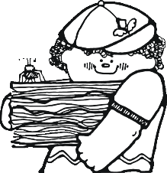

Physical
  - needs a meaningful environment to provide optimal learning experiences
  - becomes more curious of the world around him/her and how he/she relates to it
  - expresses self in words, movements and songs
  - cares for physical needs and develops good attitudes toward healthy living
  - learns to listen
  - is self-motivated and thinks independently
  - uses curiosity in productive ways to extend interests
  - earns to confront and solve problems

Intellectual
  - gains meaning and knowledge in moving from the concrete to the symbolic
  - speaks with confidence and clarity
  - expresses self through a variety of media
  - uses time efficiently and effectively
  - develops appropriate work habits

In a developmental Kindergarten, skills are integrated among the content areas. A sampling of some of the skills being developed are:

Language Arts
Motor Skills
  - throws, catches, bounces a ball
  - dresses self

  - prints name, alphabet letters and numbers

Visual and Audio Perception
  - names colors, shapes, letters
  - recognizes familiar sounds
  - identifies beginning sounds

Listening and Oral Skills
  - listens and follows directions
  - enjoys stories and poems
  - participates in classroom discussions
  - demonstrates vocabulary growth

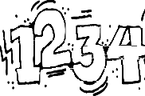
Mathematics
Understands size, position, concepts of numeracy, patterns, measurements, basic and geometric shapes, graphs and data collection.

Social Studies
The chief aim of the kindergarten social studies curriculum is to develop a respect and understanding of self, family, friends, community and respect for work.

Science
All children need an opportunity to explore, manipulate and discover as they try to find out the “what,“ “how“ and “why” of the world in which they live.
The topics that will be covered are:
  - Earth and space science
  - plants
  - animals and their young
  - seasons
  - weather
  - hygiene
  - the five senses

Creative Arts

in
A child’s first means of written expression is through his/her art work. The child is guided his/her expression through the use of paper, crayons, paints, chalk, clay and “beautiful junk”.

Music
Young children find natural delight in rhythm and sound. Children are provided with a variety of musical experiences through singing, rhythm
instruments, creative rhythms and dramatizing songs.

Pupil Evaluation

Parent-Teacher Conference
No school curriculum can satisfactorily accomplish its purpose unless there is an open two-way communication between the school and home. The school cannot understand the individual pupil and his/her needs unless it has some knowledge and understanding of the home and family. Similarly, parents
should know the experiences their child is having at school.
In kindergarten, the formal November report card is replaced
by a parent-teacher conference. You may wish to jot down any questions and/or comments you have which relate to your child’s growth and development.

Report Cards
Report cards are distributed to Kindergarten children in January, April and June.
Your child’s first year of school is very important. The Kindergarten program is planned to provide learning situations suited to the development of five-year olds. By the time that you receive your child’s first report card, you will have had at least one individual conference relating to your child’s progress.
Additional conferences can be arranged upon request by parents or the teacher.

Partners

Parent-Teacher Team
Although the first day of Kindergarten is special, it is not a true beginning, for YOU have given your child his/her start. The Kindergarten teacher recognizes your important role and will welcome you as a “partner” in your child’s continuing education. The Kindergarten teacher will seek your help and involvement in a variety of ways to make the Kindergarten experience most meaningful for your child.

Transition From Home To School
Helpful hints are listed below to help your child make a favorable adjustment to school.

Regular Routine
- Read aloud to your child daily.
- Take him/her on trips to the store, zoo, library, bank, airport, park and many other experience filled places.
- Control the time, type and number of television programs and movies your child watches.
- Allow your child to assume the responsibility of simple household tasks.
- Help your child to learn to dress himself/herself and to hang up his/her clothes.
- Teach your child to take care of his/her toilet needs.

Summer Tune Up
- Encourage your child to learn his/her full name, address and phone number.
- Establish the kind of going-to-bed, getting up, resting, playing routine at home that can continue when your child starts school.
- Your child’s clothing should be easy to manage.
- All clothes should be labeled for identification so that both your child and the teacher can identify every piece.
- Teach your child to take care of his/her toilet needs.
- If your child will be walking to school, take him/her by the
safest route several times before school begins.
- If your child will be riding to school, he/she should learn to be careful boarding or leaving vehicles and to sit quietly in a seat.
- Some children become anxious as the first day of kindergarten approaches. You may help your child overcome some fears by reading some of the following books to your child and discussing them with him/her:

- The Night Before Kindergarten by Natasha Wing and Julie Durrell
- Kindergarten Rocks by Katie Davis
- I Am Too Absolutely Small For School by Lauren Child
- Curious George’s First Day of School by Margaret and H.A. Reys
- Vera’s First Day of School by Vera Rosenberry

Starting Each Day Off Right
- Keep your child healthy and be sure he/she is well-rested and well nourished.
- Be sure your child is appropriately dressed for the forecasted weather.
- Listen to a local radio station or visit the Worcester Public Schools web page, www.worcesterschools.org for information regarding school cancellations or delays.
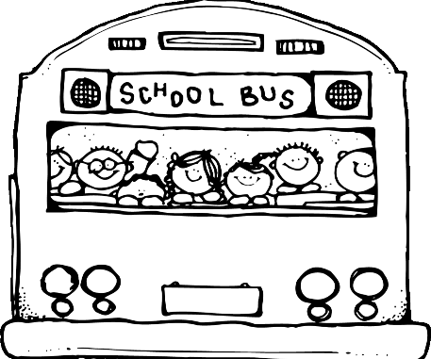
- If you send money to school with your child for any reason, put it in a sealed envelope and write your child’s name and what the money is for on the

Worcester Public Schools
outside.

WHEN SHOULD I KEEP MY CHILD HOME FROM SCHOOL

Below is the full list of possible COVID symptoms for which caregivers should monitor their children before sending them to school:

Please STAY HOME and test for COVID (home test or PCR) if your child has the
following:

❏ Fever (100.0° Fahrenheit or higher), chills, or shaking chills
❏ Difficulty breathing or shortness of breath
❏ New loss of taste or smell
❏ Muscle aches or body aches
-AND/OR-
❏ Cough (not due to other known cause, such as chronic cough)
❏ Sore throat when in combination with other symptoms
❏ Nausea, vomiting, or diarrhea when in combination with other symptoms
❏ Headache when in combination with other symptoms
❏ Fatigue, when in combination with other symptoms
❏ Nasal congestion or runny nose (not due to other known causes, such as allergies) when in combination with other symptoms

Other (non-COVID) reasons to stay home:
● A diagnosis of flu (influenza) with fever. Your child can return to school once they have no fever for 24 hours without the use of tylenol or ibuprofen.
● A diagnosis of strep throat. Your child should remain at home until they have no fever for 24 hours, and at least 12 hours after starting antibiotics.
● If your child has vomited during the previous night or in the morning.
● If your child has diarrhea during the previous night or in the morning.
● If your child has a moist productive cough, chest congestion or thick nasal drainage.
● If your child has a red or swollen eye that itches and has a yellow drainage, until your
child is under treatment.
● If your child has live head lice, until they have been treated.
● Please contact the school nurse if your child has a contagious infection such as COVID- 19, strep or flu, head lice, chicken pox, pink-eye, ringworm, impetigo or scabies.

CAN MY CHILD RETURN TO SCHOOL?

● Is your child positive for COVID-19?
● Has your child had a fever of 100.0 degrees or more in the past 24 hours?
● Has your child had acetaminophen (Tylenol) or ibuprofen (Motrin or Advil) in the past 24 hours?

If you answered NO to all 3 questions above, your child can return to school.

If you answered YES to any of these questions above, your child CAN NOT return to school. If your child is COVID positive - your child must stay home according to the latest
guidelines. Please contact your school nurse directly for guidance on a return to school date.

HOW ELSE CAN I KEEP MY CHILD HEALTHY?

● Vaccinate:
○ Make sure that everybody in your family is up to date with their flu and COVID vaccines. These vaccines are safe and make a difference!

● Hand Wash:
○ Practice good hand-washing with soap and water, or use of hand sanitizer
frequently.
● Cough Etiquette:
○ Remind your child to cover their nose and mouth with a tissue when coughing or sneezing, or cough and sneeze into their elbows.
○ Masking is no longer required outside the health offices.
However, please consider having your child wear a mask in school if they have a cough or other respiratory symptoms.

It is always wise to consult with your physician if any symptoms persist and become severe.

On My Own

- Be interested and appreciative when your child brings home samples of his/her work. Have a display corner somewhere in your home.
- Listen appreciatively to his/her comments and stories.
- Let your child tell you about school – but don’t pester him/her to tell you what he/she did in school. Encourage your child to talk by asking questions such as:
Did you learn a new song today? What was today’s story about?
Did you work with numbers today? Did you work with letters today?
Did you paint today?
- When your child brings home seemingly unidentifiable pieces of art work, encourage him/her to tell you about it rather than asking, “What is it?”

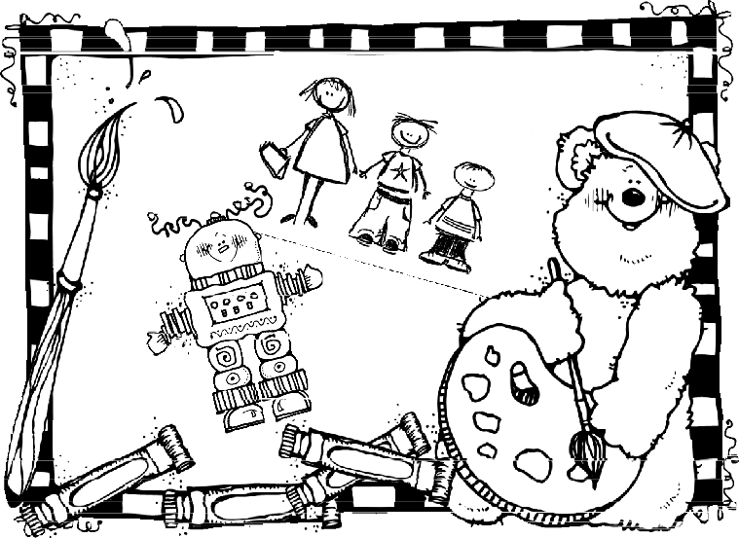

Involvement In Your School
The following organizations are a viable means of demonstrating your interest in becoming an active participant in your child’s education and your school system:

Parent Organizations
Contact your school organization president.

Volunteer Work
All of our schools offer a variety of volunteer assignments for interested parents. To learn more about these opportunities contact your School Office.

School Site Council
Contact your principal.

City Wide Council
Special Education Parent Advisory Council, English Learner Parent Advisory Council,
City Wide Parent Planning Council.

School Committee Meeting
Try to attend School Committee meetings frequently so that you may be knowledgeable of the decision-making policies that will affect your child and your school system. Most Worcester School Committee meetings are held every other Thursday at 6:00PM in the Esther Howland South Chamber of Worcester City Hall, 455 Main Street. Meeting dates and times vary; please verify the meeting details on the Worcester Public Schools website.

I’M FIVE (Developmentally)
I am growing fast.
I need to run and play.
I can use my big muscles.
I'm beginning to use my little muscles, but sometimes it's hard.
My eyes are not ready to do fine work. I am farsighted.
I like to feel and see things. I learn by doing things.
I like to find out about new things.
I like to build big things, but they aren't always perfect.
I want to try things myself, but I like to know there's someone there to help.
I like to talk.
I want to find out about everything. I like to make-believe.
Sometimes I think that make-believe is real.
I like to play that I am big.
I'm learning to work and play with many children.
I want to be loved even when I'm bad.
I need to know what big people expect of me, although I may not always do it.

MOST OF ALL ...
I’m Me

“IN ACCORDANCE WITH FEDERAL AND STATE LAWS INCLUDING, BUT NOT LIMITING TO TITLE IX AND CHAPTER 622, THE WORCESTER PUBLIC SCHOOLS IS COMMITTED TO ALL PERSONS WHO ARE ENTITLED TO ATTEND PUBLIC SCHOOLS, WORK AND ADVANCE ON THE BASIS OF MERIT AND ABILITY REGARDLESS OF RACE, COLOR, SEX, AGE, RELIGION, NATIONAL ORIGIN OR HANDICAP”
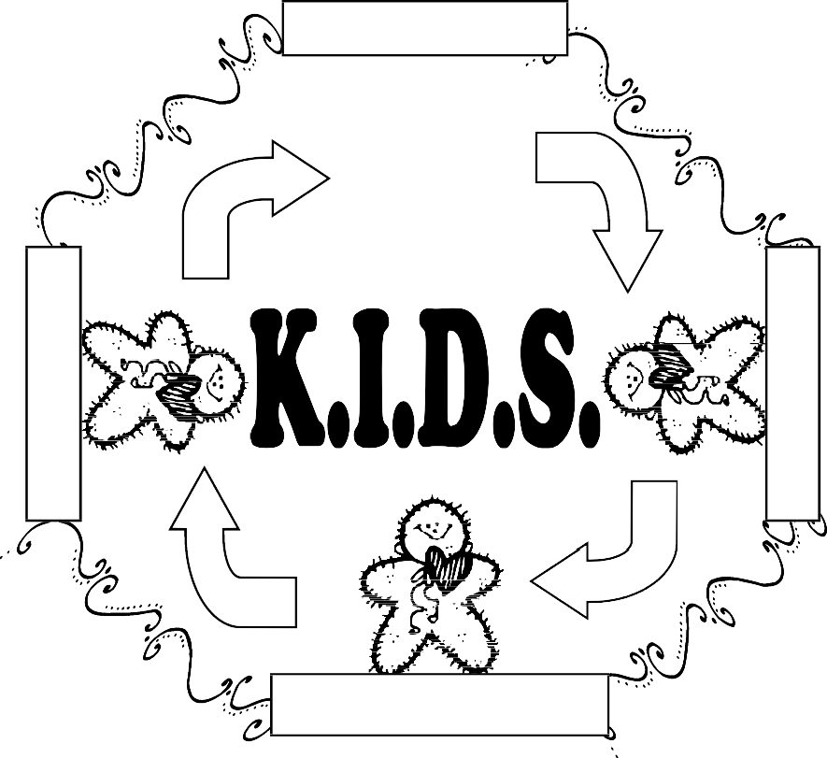

Administration
Resource People
Teachers
Parents

Laurie Kuczka
Director of Head Start and Early Childhood

Designed by Elizabeth Vecchio

The Worcester Public Schools is an Equal Opportunity/Affirmative Action Employer/Educational Institution and does not discriminate regardless of race, color, gender, age, religion, national origin, gender identity, marital status, sexual orientation, disability or homelessness. The Worcester Public Schools provides equal access to employment and the full range of general, occupational and vocational education programs. For more information relating to Equal Opportunity/Affirmative Action contact the Human Resource Manager, 20 Irving Street, Worcester, MA 01609, 508-799-3020.

