Elementary MATH CARD GAMES
Materials: A pack of playing cards!

Preschool and Kindergarten: Builder’s Paradise

This counting and sequencing card game is a wonderful break from your normal math routine, and a fun chance for your kids to practice their skills. The best part? There’s no prep necessary! Just grab a deck of cards! Builder’s Paradise is a perfect Kindergarten card game, or you can even play with your preschoolers.

Setting up the Game:
To get started, grab a single deck of cards and remove the face cards.
Once shuffled, deal all the remaining cards among the players.

How to Play Builder’s Paradise:
The object of the game is to be the first player to get rid of all of their cards.
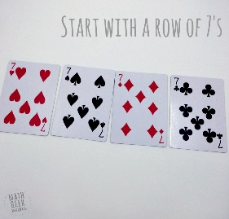
To begin, players take turns putting down one or more cards above or below a seven, in sequence, according to their suit.
For instance, in the first round players will play six’s and eight’s.
If a player cannot play anything, they pass that turn. If no one that round can play a card, the game is over and the player with the fewest cards wins.
This is so simple, and will not take much time to set up and play, but is a great way to help kids work on important math concepts without even realizing it.
Want a fun variation? Try building the cards out both vertically and horizontally.

Grades K. 1 and 2: Total of 10 (or 15 or 20)
In total of 10, students are trying to find cards that total 10. The goal is to empty their total of 10 board so that they have no cards left.
I love this game because it's a solitaire style game...and it can be played independently or as a team. Here's how to play!
Lay out 20 cards in a 5x4 array.

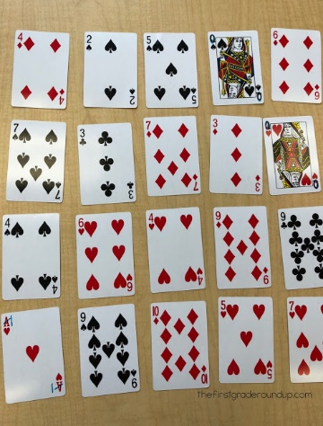

Then, pick up cards that total 10.
When I model this game whole group, students quickly find pairs that make 10. And then, we get stuck because there are no more card pairs to make 10. So, I push them by saying, "I still see cards that can make 10. Do you?"
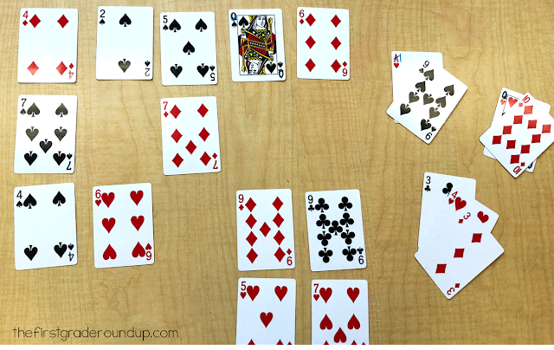
And we discover that we can use 3 or more numbers to make 10!
The game is over when we cannot make any more totals of 10. Again, the goal is to have as few cards left over as possible. This is actually difficult to clear the board entirely. This game can easily be differentiated by playing total of 20 with kids who are ready.

Grades 1, 2, 3: Add It Up By Tens
This game is the next level up from total of 10. Set up this game just like total of 10 in an array of 5x4. This time you will be adding all of the numbers by composing groups of ten. As you find a total of 10, leave the pile to the side. When no more tens can be found, add up the groups of tens and the left overs to find the total.
Then, students record how they found the total...
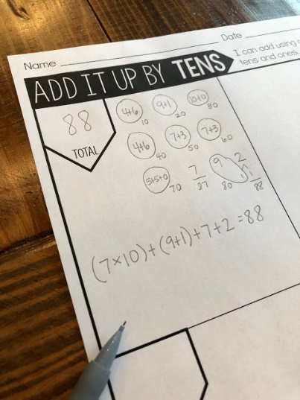
This game because it pushes kids to use a base 10 strategy to add. This is great for kiddos who insist on counting on or all and never attempt to compose 10s!
Grades 1, 2, 3: Tens Go Fish
This game is basically like Go Fish except you are pairing cards that make ten. For this game, I always post a sentence frame for students to use as they play.
"I have 2. Do you have an 8 to make 10?"

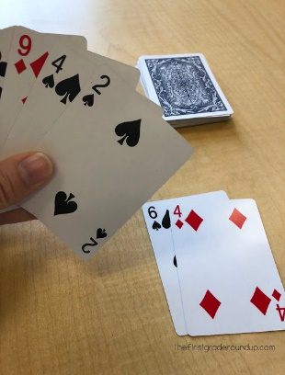
This game is played with 2-4 players and is great to play before playing total of 10 to build fluency with pairs of 10.
Grades 1, 2, 3, 4: Sum of 10 Pyramid Solitaire Card Game
Are you game?
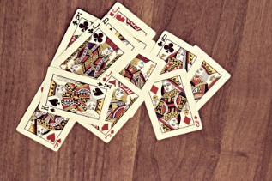
First off, grab a deck of playing cards, removing the Jokers, Kings, Queens and Jacks.
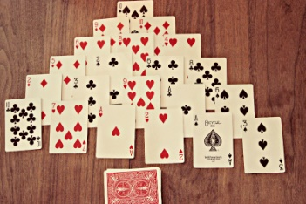
Shuffle your deck and place 21 of the cards face up in a 6-row pyramid. You should have 19 cards leftover which becomes the DRAW pile. There are two rules that must be followed when playing this Pyramid Solitaire Game:
- Only fully exposed cards can be played at any time. That means, to start, only the bottom 6 cards can be considered until you start removing bottom cards.
- You can only remove cards that equal 10, and only up to two cards at a time. For instance, you can remove a 10, or you can remove a 6 and a 4 (because added together they equal 10), but you can't remove a 2, 4, and a 4, even though, added up, they equal 10.
Let's play a few rounds and see if we can get you familiar with this game:
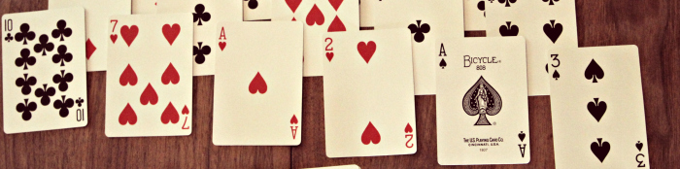
Take a look at the bottom row of 6 cards (pictured above). Do you see a card that equals 10, or two different cards that added together equal 10?
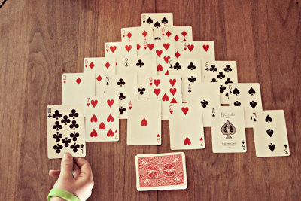
Yes! We have a 10.
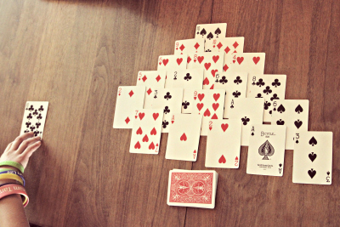
Place it in the discard pile.
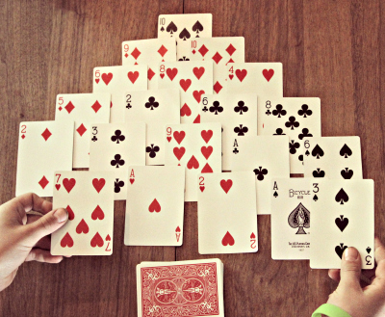
The 7 and 3 can also be picked up and discarded.
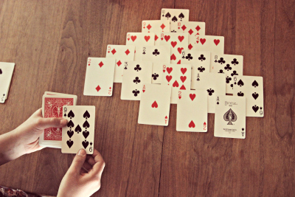
Since there are no more open cards that can be added to get the sum of 10, we need to pick a card from the DRAW pile. A Nine of Clubs!
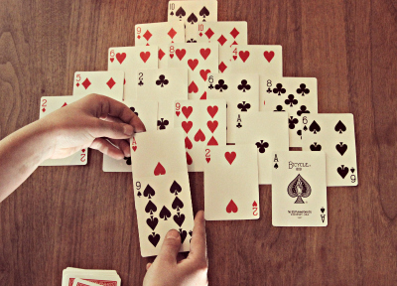
We can pair that with the Ace and get a sum of 10! Cards that don't form matches are put in the DISCARD pile face up. You can use the top card only of the DISCARD pile in any other future match-ups.
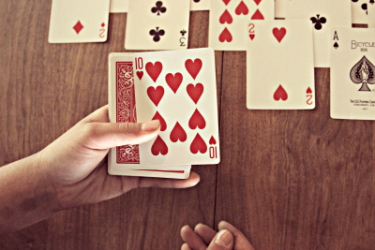
We draw again and get a Ten of Hearts! Instant success!
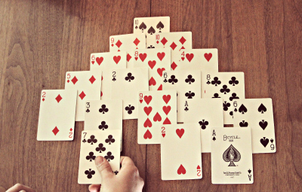
When we drew another card, we got a Seven of Clubs and was able to pair it to the fully exposed Three of Clubs on the next level, to make a sum of 10.
Cards that do not form a match are placed
Continue on until all 19 cards that were not part of the original pyramid have been turned over, and when you have no more cards to work with; that is, until no other card can be combined to make a sum of ten.
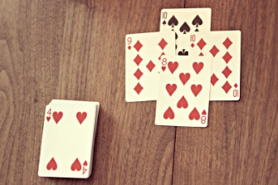
As you can see, we have four cards left. The score is the number of cards remaining, so our score is 4. The smaller the score, the better!

Grades 2, 3, 4: Close Call
Skills Focus: Addition of 2-digit numbers, mental math calculations and problem solving.
While the focus of this 2-digit addition card game is addition and mental math practice, it will also develop and encourage problem solving skills.
Because the goal is to get as close to 100 as possible, kids have to really think about which cards to choose and what numbers to make with them.
In addition, this will help deepen an understanding of place value as they begin to realize what values are better suited for the tens place, and what numbers are better for the ones place to achieve their goal.

How to Play Close Call:
The object of this game is to accumulate the highest score by coming closer to the goal than your opponent.
Start with a complete deck of cards. Ace = 1, Joker = 0 and all tens and other face cards are removed. Shuffle the deck and deal each player 6 cards.
Players then select 4 of the cards to create two 2-digit numbers. The object is to create two numbers that when added together come as close to 100 as possible, without going over.
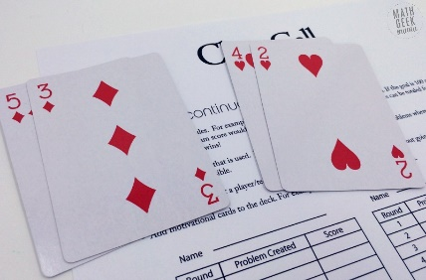
For example, in this hand I selected the cards 2,3,4, and 5.
I was then able to create the numbers 53 and 42, which when added together total 95.
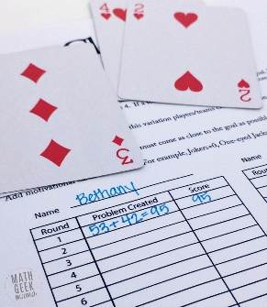

How to Win Close Call:
The player with the total closest to 100 wins the round and 1 point. In the event of a tie, each player receives a point.
After playing 5 rounds, the player with the most points wins.
Alternatively, you could continue playing rounds until someone reaches 5 points.
To further aid with addition practice, you could also add the total from each round to calculate the total points. Then the player with the highest score wins.

Variations to the Game:
If you’d like to play this with younger kids, deal 4 cards to each and select 2 cards to get as close to ten as possible, without going over.
Or to practice subtraction instead, change the rules to subtract 2 numbers to get as close to zero as possible.
Or for a greater challenge for older kids, practice with integer operations. Make black cards positive and red cards negative, and again, challenge kids to combine numbers to get as close to zero as possible.

Grades 3, 4, 5 ,6: Use order of operations to get to 24
Math can be Fun too! The popular 24 Math Game is a huge hit in classrooms and homes around the world. A sure way for kids to do better at math is by helping them to have a good time while learning!
Play 24 Game Using a Deck of Playing Cards
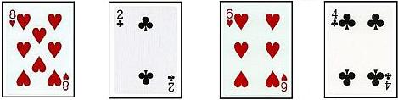
An easy way to play the game is using an ordinary deck of cards. Aces are given a value of 1. Be sure to remove all of the face cards from the deck.
- The object of the game is to arrange four cards and using the four basic mathematical operations (addition, subtraction, multiplication, and division) to get a total of 24. Each player can use the Parentheses can also be used along with these four basic operations.
- Choose one person to deal the cards. The dealer deals out four cards face-down to each player.
- When all the cards are dealt to each player, all of the players will turn their cards over face-up in front of them and try to arrange their cards in any order and use three of the four math operations to reach the total of 24. One set of parentheses may be used.
- The first player that comes up with a total of 24 first is awarded a point. As a parent/guardian overseeing the game, you might want to make sure their solution is valid.
- If nobody comes up with a solution no points are given for that round.
- Whoever has the most points after a predetermined number of rounds wins the game.
Take a look at the picture below. This is a good solution.
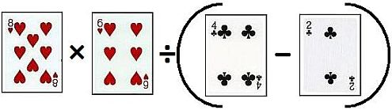
223Save
Have Fun Playing.

Grades 2, 3, 4, 5, 6: Triple Digit Dare
This game plays very much like War, with students using the three cards they are dealt to create a 3-digit number.

Basic Version
- Use a standard deck of playing cards with the 10s, Jacks, Queens, and Kings removed. Aces count as 1,
Queens as zeros, and Jokers as Wild cards that can be used for any digit.
- Deal each player 3 cards.
- Players use the cards to create the largest 3-digit number possible.
- Players show their cards, and the player with the greatest 3-digit number takes all the cards.
- Play continues with 3 more cards for each player.
You could easily vary this game to use 2-digit, 4-digit, or even larger numbers.

Advanced Version
Once the students master the basic version, introduce a new version of the game, this one with an added twist of strategy.
- Same standard deck of cards with the same cards removed.
- Each player still gets 3 cards.
- Remaining cards are placed face down in the middle of the table.
- After each player looks at their cards and determines their greatest 3-digit number, the fun starts! Taking turns, each player has the option to…
  - Stick–keep their 3 cards
  - Swap–remove one card from their hand and take a new card from the pile in the middle of the table
  - Steal–trade a card from their hand for a card from any other player’s hand (without looking at what card they are picking)
- After all players have had a turn to adjust their cards, players show their cards and the greatest 3-digit number wins.

RULES: No peeking!

