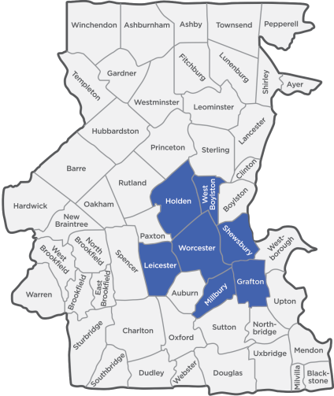
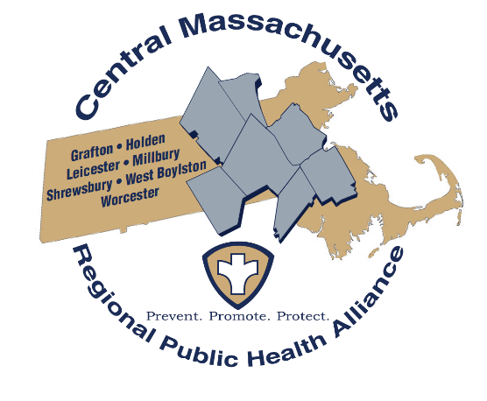

Building a Better Regional, Comprehensive Services Model to Improve Public Health

What is the Central Mass Regional Public Health Alliance (CMRPHA)?
The Central Mass Regional Public Health Alliance is a coalition of six municipalities (Towns of Holden, Leicester, Millbury, Shrewsbury, and West Boylston and the City of Worcester) working cooperatively to create and sustain a viable, cost-effective, and labor-efficient regional public health district. The regional health district provides a comprehensive array of services to partner municipalities through a single organization managed by Worcester’s Division of Public Health. The inspiration to develop a regional alliance arose from the considerable disparity in size, available resources, and kinds and types of resources offered by each municipality.

- Build a Road to Sustainability
- Improve Organizational Effectiveness
- Mobilize a Community Coordinated Approach
- Make Data-Driven and Evidence-Based Decisions
- Sustain Public Health Accreditation

Key Goals

Why are we conducting a Regional Youth Health Survey?
As part of this effort, a comprehensive survey of youth health behaviors is being conducted in 2019, led by the City of Worcester’s Division of Public Health. The Regional Youth Health Survey contains questions that allow us to make data-driven and evidence-based decisions about the health needs and strengths of young people in the CMRPHA communities. The information gathered will be used to identify priority areas for future health improvement work in the CMRPHA communities. The survey contains questions that ask about nutrition, physical activity, sexual activity, injuries, violence, bullying, tobacco, alcohol, and other drug use.

The Worcester Public School District is taking part in the Regional Youth Health Survey. This survey is sponsored by Worcester Division of Public Health. The survey will ask about the health behaviors of 7th and 8th grade students. The survey will ask about nutrition, physical activity, sexual health, injury, violence, bullying, tobacco, alcohol, and other drug use.
Students will be asked to fill out the survey the week of February 14, 2022. The survey takes about 45 minutes for the students to complete.
Doing this electronic survey will cause little or no risk to your child. The only potential risk is that some students might find certain questions to be sensitive. The survey has been designed to protect your child’s privacy. Students will not put their names on the survey. Also, no school or student will ever be mentioned by name in a report of the results. Your child will get no benefit right away from taking part in the survey. The results of this survey will help your child and other children in the future. We would like all students to take part in the survey, but the survey is voluntary. No action will be taken against the school, you, or your child if your child does not take the survey. Students can skip any questions they do not wish to answer. In addition, students may stop taking the survey at any point without penalty. If you would like to see the survey, a copy is available in the Principal’s Office.

Please read the section below and check the box only if you do not want your child to take part in the survey. If you check the box “no” below, then sign this form and return it to the school within 3 days. Please see the other side of this form for more facts about the survey.

If your child’s school cannot answer your questions about the survey, please email Nikki Nixon, Epidemiologist at Worcester Division of Public Health at nixonn@worcesterma.gov . Thank you.

Student’s name:___________________________________________ Grade: ______________
Student’s school:___________________________________________

I have read this form and know what the survey is about.
[ ] NO, my child may not take part in this survey.
Parent’s signature:________________________________________ Date:_________________
Phone number: __________________________________________

