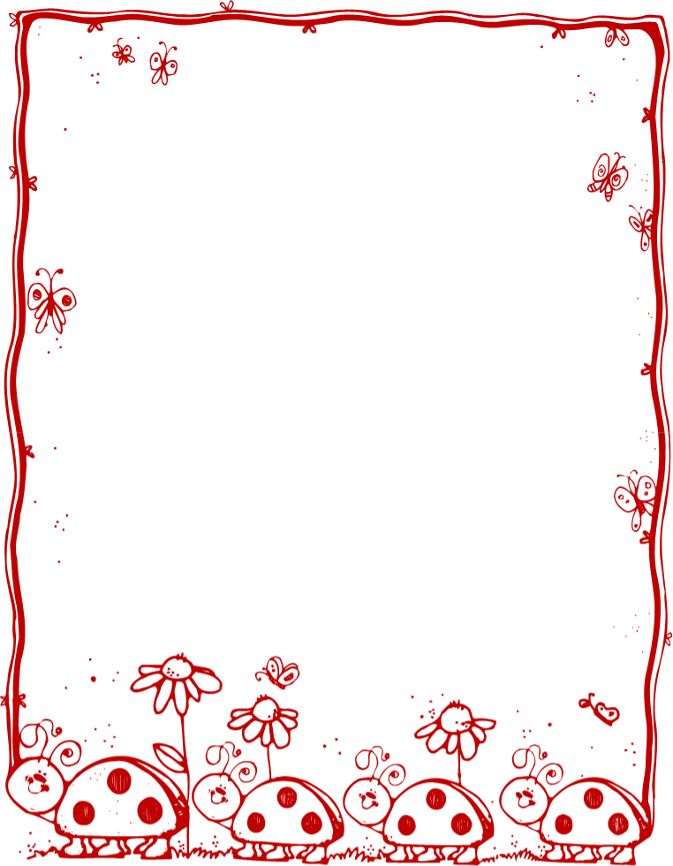

## ***MMƆFRAASE NHWEHWԐMU***

**WHAN:** Yԑbԑyԑ saa nhwehwԑmu yi ama mmɔfra a’wɔn adi nfie miensa anaa ennan a’ wɔn hia mmoa anaa wadidem (**Worcester Tenabeafo Nkoara**). a’wɔpԑsԑ wɔshԑ ase wɔ mbɔdɔmaba sukuu bosome Ɔsannaa (August)

**ADEԐBEN:** Nhwehwԑmu a’ԑwɔ saa nnidisoɔ yi:

* Nimdeԑ/Adesua * Nneyԑԑ * Aniso Adehunu

* Kasa * Ɔkasa

**Ԑda B**ԑ**n:** Mmrԑ Bԑn: Ԑhenefa**:**

Yawoada, Kotonimma 12, 2022 9:00 a.m.-1:00 p.m. Quinsigamond El - 14 Blackstone River Rd Efiada, Kotonimma 13, 2022 9:00 a.m.-1:00 p.m. Worcester Arts Magnet- 315 St. Nicholas Ave Efiada, Kotonimma 20, 2022 9:00 a.m.-1:00 p.m. Roosevelt Elementary- 1006 Grafton St.

**Nsԑm hia a’ewomu:** Frԑ Ahomatorofo nɔma: 508-799-8165

• Wohia Nkaeԑbɔ nhyiamuda.

• Frԑ ahomatorofoɔ nɔma na gye nhyiamuda/nshyeshyԑyԑ ne debia da pɔtee a’wopԑsԑ wone sukuu nhwԑsofoɔ beshia.

**Asoyԑ:**

**Awofo a’wɔn Mmɔfra adi nfie miensa anaa ԑnnan**

# **Worcester Aban Nsukuu**

# 

## Mmɔfraase Nhwehwԑmu wɔn a’wohia mmoa anaa sԑ wadidem

TWI

**Ԑwɔsԑ abɔfra biara a’ na awofo/ahwԑsofoɔ nka ne ho gye tumi krataa fi ne awofo nkyԑn ansaa na yatumi ayԑ nhwehw3mu yi.**